The laboratory work 12

Create a virtual network
- From the Azure portal menu, select Create a resource. From the Azure Marketplace, select Networking > Virtual network.
- In Create virtual network, enter or select this information:
Table 1
Setting | Value
Subscription | Select your subscription.
Resource group | Select Create new, enter myResourceGroup, then select OK.
Name | Enter myVirtualNetwork.
Location | Select East US.
- Select Next: IP Addresses, and for IPv4 address space, enter 10.1.0.0/16.
- Select Add subnet, then enter myVirtualSubnet for Subnet name and 10.1.0.0/24 for Subnet address range.
- Select Add, then select Review + create. Leave the rest as default and select Create.
- In Create virtual network, select Create.

Create virtual machines
Create two VMs in the virtual network:

Create the first VM
- From the Azure portal menu, select Create a resource.
- From the Azure Marketplace, select Compute > Windows Server 2019 Datacenter. Select Create.
- In Create a virtual machine - Basics, enter or select this information:
Table 2
Setting | Value
Project details
Subscription | Select your subscription.
Resource group | Select myResourceGroup. You created this resource group in the previous section.
Instance details
Virtual machine name | Enter myVm1.
Region | Select East US.
Availability options | Default to No infrastructure redundancy required.
Image | Default to Windows Server 2019 Datacenter.
Size | Default to Standard DS1 v2.
Administrator account
Username | Enter a username of your choosing.
Password | Enter a password of your choosing. The password must be at least 12 characters long and meet the defined complexity requirements.
Confirm Password | Re-enter password.
Inbound port rules
Public inbound ports | Select Allow selected ports.
Select inbound ports | Enter HTTP (80) and RDP (3389).
Save money
Already have a Windows license? | Default to No.
- Select Next: Disks.
- In Create a virtual machine - Disks, keep the defaults and select Next: Networking.
- In Create a virtual machine - Networking, select this information:
Table 3
Setting | Value
Virtual network | Default to myVirtualNetwork.
Subnet | Default to myVirtualSubnet (10.1.0.0/24).
Public IP | Default to (new) myVm-ip.
NIC network security group | Default to Basic.
Public inbound ports | Default to Allow selected ports.
Select inbound ports | Default to HTTP and RDP.
- Select Next: Management.
- In Create a virtual machine - Management, for Diagnostics storage account, select Create New.
- In Create storage account, enter or select this information:
Table 4
Setting | Value
Name | Enter myvmstorageaccount. If this name is taken, create a unique name.
Account kind | Default to Storage (general purpose v1).
Performance | Default to Standard.
Replication | Default to Locally-redundant storage (LRS).
- Select OK, then select Review + create. You're taken to the Review + create page where Azure validates your configuration.
- When you see the Validation passed message, select Create.

Create the second VM
Repeat the procedure in the previous section to create another virtual machine.

Connect to a VM from the internet
After you've created myVm1, connect to the internet.
- In the Azure portal, search for and select myVm1.
- Select Connect, then RDP.
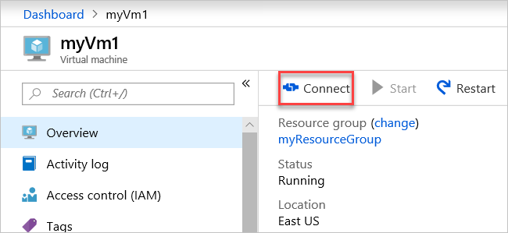
The Connect page opens.
- Select Download RDP File. Azure creates a Remote Desktop Protocol (.rdp) file and downloads it to your computer.
- Open the RDP file. If prompted, select Connect.
- Enter the username and password you specified when creating the VM.
- Select OK.
- You may receive a certificate warning when you sign in. If you receive a certificate warning, select Yes or Continue.
- Once the VM desktop appears, minimize it to go back to your local desktop.

Communicate between VMs
- In the Remote Desktop of myVm1, open PowerShell.
- Enter ping myVm2.
You'll receive a message similar to this output:
• Pinging myVm2.0v0zze1s0uiedpvtxz5z0r0cxg.bx.internal.clouda
Request timed out.
Request timed out.
Request timed out.
Request timed out.

Ping statistics for 10.1.0.5:
Packets: Sent = 4, Received = 0, Lost = 4 (100% loss),
The ping fails, because ping uses the Internet Control Message Protocol (ICMP). By default, ICMP isn't allowed through the Windows firewall.
• To allow myVm2 to ping myVm1 in a later step, enter this command:
PowerShell
• New-NetFirewallRule –DisplayName "Allow ICMPv4-In" –Protocol ICMPv4
This command allows ICMP inbound through the Windows firewall:
• Close the remote desktop connection to myVm1.
• Complete the steps in Connect to a VM from the internet again, but connect to myVm2.
• From a command prompt, enter ping myvm1.
You'll get back something like this message:
• Pinging myVm1.0v0zze1s0uiedpvtxz5z0r0cxg.bx.internal.cloudapp.net [10.1.0.4] with 32 bytes of data:
Reply from 10.1.0.4: bytes=32 time=1ms TTL=128
Reply from 10.1.0.4: bytes=32 time<1ms TTL=128
Reply from 10.1.0.4: bytes=32 time<1ms TTL=128
Reply from 10.1.0.4: bytes=32 time<1ms TTL=128

Ping statistics for 10.1.0.4:
Packets: Sent = 4, Received = 4, Lost = 0 (0% loss),
Approximate round trip times in milli-seconds:
Minimum = 0ms, Maximum = 1ms, Average = 0ms
You receive replies from myVm1, because you allowed ICMP through the Windows firewall on the myVm1 VM in step 3.
• Close the remote desktop connection to myVm2.

